ShareBot.

**Version 0.1**

**Author:** Tanumay Das

**Initial Setup:**

One of our development mindset was to keep the solution lightweight and minimum setup steps for the users , both before and after installation. After installation admin needs to only make the “ShareBot” tab available for the targeted users/profiles.

To enable the “ShareBot” tab follow the below steps: -

* Setup -> Profiles -> Click on the targeted profile -> Edit
* Scroll down to Tab Settings

Find “Share Bot” and change the dropdown to “Default On”

After this you are all set to use the tool. Navigate to the Share Bot tab and the tool is up and running.

**A quick Walkthrough:**

On the first load you are presented with all the custom objects of the org and few selected standard objects. After that you can apply the selective loading of your objects of choice. For these selective loading options click on the “Preferences” button and the rest is self-explanatory.

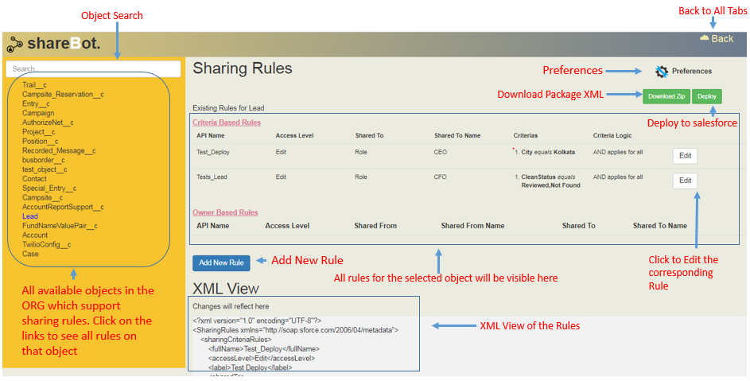

In the left side-bar all the loaded object will be displayed, an active search bar is there to look for any certain object/object group. In the mid-section two tables show all the available Sharing rules both Criteria based and Owner Based for the selected object. Each rule is accompanied by an “Edit” button to edit the rule. An “Add New Rule” button is there to add new rules and the interface is same as salesforce standard sharing rule creation system, so it is a familiar sight for the developers. After designing the rules “Deploy” can be clicked to deploy all rules in the org. The only scenario that needs a walkthrough is the cloning capability of this tool.

**Cloning Rules:**

If the developer needs to create multiple rules in an object with a repeating pattern, then this tool can do this in a single go. For an example:

Example#1

* Share the record with Role CFO-AU if the records country code field value is AU
* Share the record with Role CFO-JP if the records country code field value is JP
* Share the record with Role CFO-TK if the records country code field value is TK
* Share the record with Role CFO-BR if the records country code field value is BR
* Share the record with Role CFO-BG if the records country code field value is BG

To achieve this the user will have to navigate to the Object and click “Add New Rule” and then the inputs will look like the following.

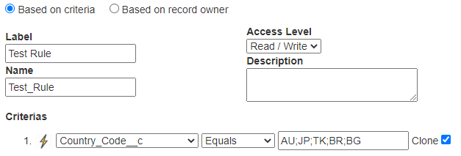

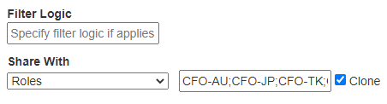

And this will result in:

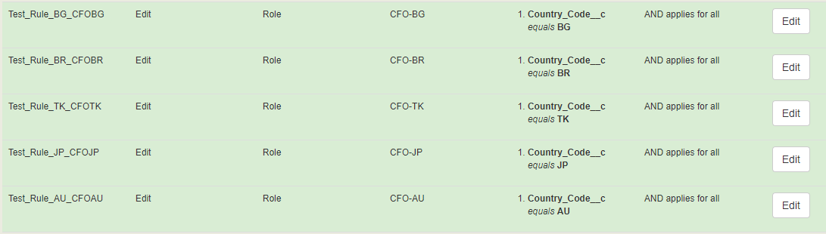

Example #2

Now if a developer wishes to create these 5 rules in 5 objects at once then he can choose the add to multiple link at the bottom of the “Add New Rule” dialog and the selection pane for multiple objects comes up. After selection of multiple objects are completed, click on the “Done” on the bottom and then only the objects are registered for cloning.

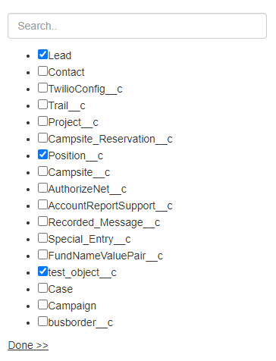

After selection Clicking on “Add” creates the above 5 rules in 5 additional objects in a single go. The user is then free to navigate to any highlighted object and change any value / name / label for the newly created rules. After the intended changes are done, a single click on the “Deploy” button will push the changes to the org. Before deploying a user is free to download the deployment package by clicking on the “Download” button.

**Repeating field/criteria Cloning**

In some scenarios a field is used multiple times in a criterion with different values or with different operators. In that case the user may use the lightning icon beside each criteria to multiply it based on the available values.

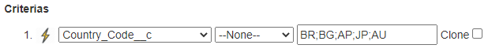

Clinking on the Lightning icon results in:

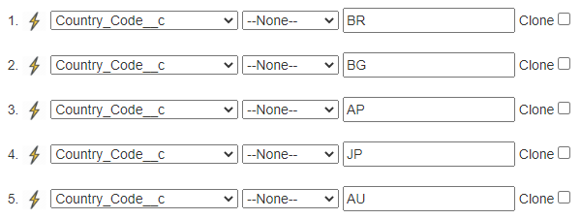

Now you can change the new rows with different operators and use them in filter logic as per your need.

**Preferences Overview**

The preferences tab is self-explanatory and simple. The settings are stored locally in browser and not in the org where the tool is installed.

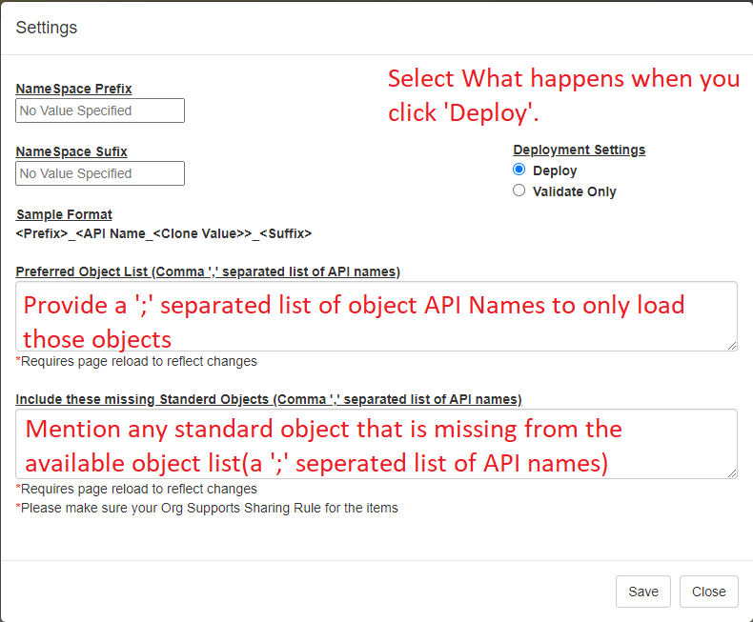

For a detailed user guide and any other information please go through the attached detailed user guide.

